how to update search_path.json：
search_path provide input to ``` search = soup.find(id=search_sting)```

search_path.json contains 5 elements for each domain. But there are only two of them we need to consider:
- search string : string to search for
- seatch method:
  - 0 : soup.find(id=search_sting)
  - 1:soup.find(class_=search_sting)"
  - 2:soup.find(type=search_sting);
  - 3:soup.find(class_=search_sting) with condition (“special Price”) see getPrice.py :88
  - 4:soup.find(meta, attrs = {attrs})
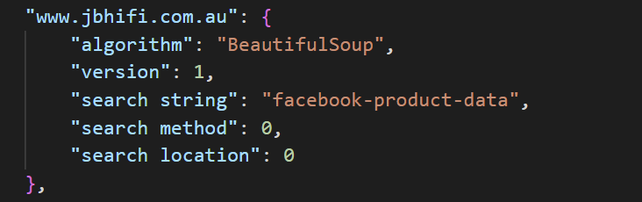
To update or added new domain:
- Go to the product page.
- High-light the price
- Right click and inspect
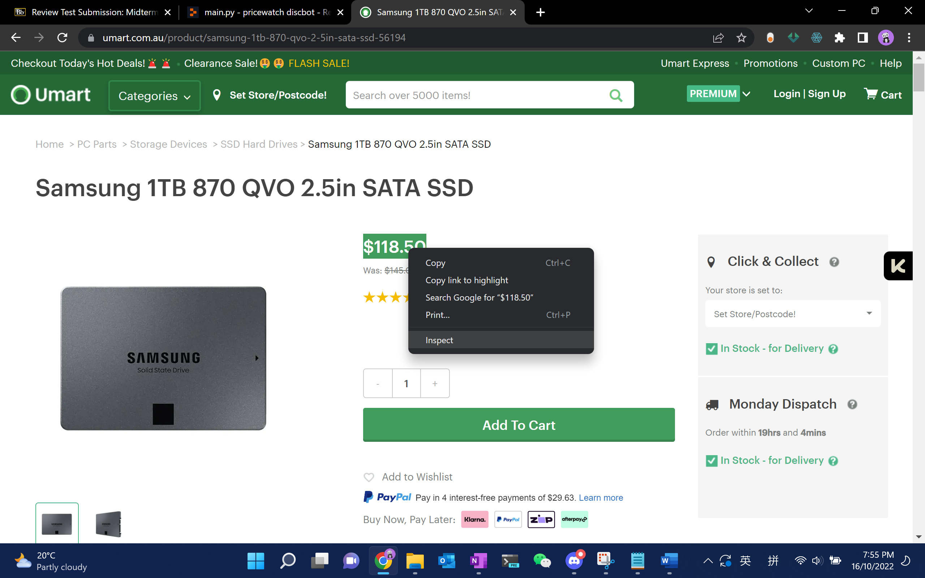
- We should have html like below
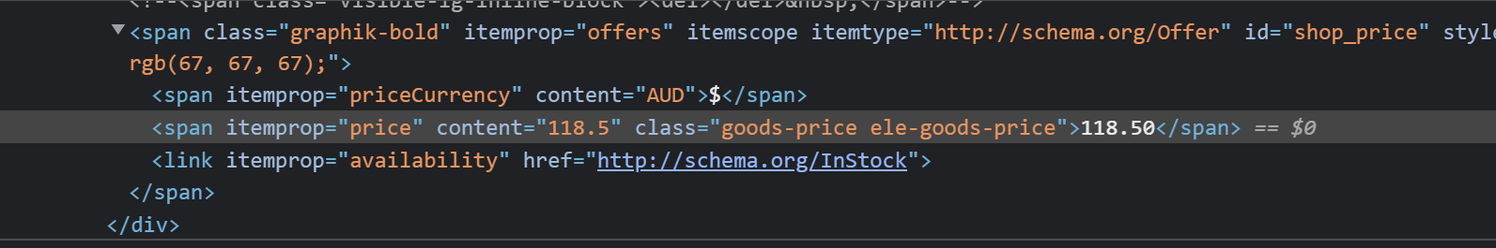
Find id if possible, if id cannot be found then try find class
In this case id = “shop_price” is found
Therefor , search method = 0 , search string = “shop_price”

